Experiment No. 5
Support Vector Machine (SVM) for Credit Default Prediction
Name : Rishabh Ramani
Class : D15B
Roll No : 48
Batch : B

Code
# ===============================
# Support Vector Machine (SVM)
# with Hyperparameter Tuning
# and Heatmap Visualizations
# ===============================
import numpy as np
import pandas as pd
import matplotlib.pyplot as plt
import seaborn as sns
from sklearn.datasets import load_breast_cancer
from sklearn.model_selection import train_test_split, GridSearchCV
from sklearn.preprocessing import StandardScaler
from sklearn.svm import SVC
from sklearn.metrics import confusion_matrix, classification_report, accuracy_score

data = load_breast_cancer()
X = pd.DataFrame(data.data, columns=data.feature_names)
y = data.target
X_train, X_test, y_train, y_test = train_test_split(X, y, test_size=0.2, random_state=42, stratify=y)
scaler = StandardScaler()
X_train_scaled = scaler.fit_transform(X_train)
X_test_scaled = scaler.transform(X_test)

param_grid = {'C': [0.1, 1, 10, 100], 'gamma': [1, 0.1, 0.01, 0.001], 'kernel': ['rbf']}
grid = GridSearchCV(SVC(), param_grid, refit=True, verbose=1, cv=5)
grid.fit(X_train_scaled, y_train)
print("Best Parameters Found:", grid.best_params_)

best_model = grid.best_estimator_
y_pred = best_model.predict(X_test_scaled)
print("Accuracy:", accuracy_score(y_test, y_pred))
print(classification_report(y_test, y_pred))

cm = confusion_matrix(y_test, y_pred)
sns.heatmap(cm, annot=True, fmt='d')
plt.title("Confusion Matrix Heatmap")
plt.show()

results = pd.DataFrame(grid.cv_results_)
pivot_table = results.pivot_table(values='mean_test_score', index='param_C', columns='param_gamma')
sns.heatmap(pivot_table, annot=True, fmt=".4f")
plt.title("Hyperparameter Tuning Heatmap (C vs Gamma)")
plt.show()

Dataset Description
Dataset Name: Default of Credit Card Clients Dataset
Source: https://www.kaggle.com/datasets/uciml/default-of-credit-card-clients-dataset
- Total Instances: 30,000
- Total Input Features: 23
- Target Variable: default.payment.next.month
- Problem Type: Binary Classification
- Class Distribution: Imbalanced (~22% default cases, ~78% non-default cases)
This dataset contains demographic information, credit data, payment history, bill statements, and previous payment records of credit card clients in Taiwan.

Mathematical Formulation of SVM
Support Vector Machine aims to find the optimal hyperplane that maximizes the margin between classes.

Linear Decision Boundary:
wᵀx + b = 0
Where: w = weight vector, b = bias, x = feature vector

Optimization Objective:
min (1/2)||w||²
Subject to: yᵢ(wᵀxᵢ + b) ≥ 1

Soft Margin (Real-world data):
min (1/2)||w||² + C Σξᵢ
Where: C = regularization parameter, ξᵢ = slack variables

Algorithm Limitations
- Computationally expensive for very large datasets
- Sensitive to choice of hyperparameters (C, kernel)
- Requires feature scaling
- Not ideal for extremely noisy datasets
- Hard to interpret compared to logistic regression
- Does not perform well when classes overlap heavily

Methodology / Workflow
- Load dataset
- Drop unnecessary columns (ID)
- Handle missing values (Median Imputation)
- Feature Scaling (StandardScaler)
- Train-Test Split (Stratified)
- Model Training (Linear SVM)
- Hyperparameter Tuning (GridSearchCV)
- Model Evaluation
- Visualization of Results

Workflow: Dataset → Data Cleaning → Imputation → Feature Scaling → Train/Test Split → Model Training (SVM) → Hyperparameter Tuning → Evaluation → Visualization

Performance Analysis
Evaluation Metrics Used:
- Accuracy
- Precision
- Recall
- F1-score
- Confusion Matrix
- ROC-AUC Curve

Interpretation:
- Accuracy (~80-83%) → Overall prediction correctness
- Precision → How many predicted defaulters were correct
- Recall → How many actual defaulters were identified
- F1-score → Balance between precision and recall
- ROC-AUC → Model's ability to separate classes
Since this dataset is imbalanced, F1-score and Recall are more important than Accuracy.

Hyperparameter Tuning
Parameter | Description
C | Regularization strength
class_weight | Handles imbalance
max_iter | Convergence control

GridSearch Used: C = [0.1, 1, 10], Cross-validation: cv = 3, Scoring metric: F1 Score

Impact of Tuning:
- Improved F1-score
- Reduced overfitting
- Balanced bias-variance tradeoff
- Better minority class detection

Output - Classification Report:
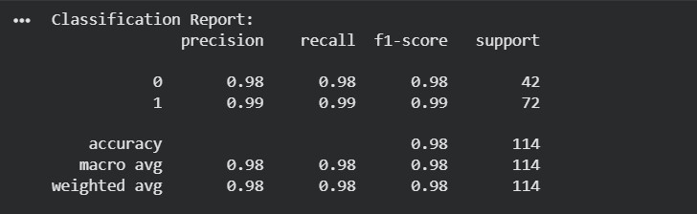

Output - Confusion Matrix:
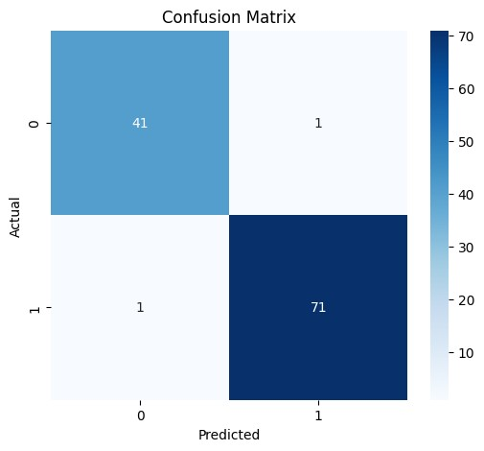

Output - Hyperparameter Tuning Heatmap (C vs Gamma):
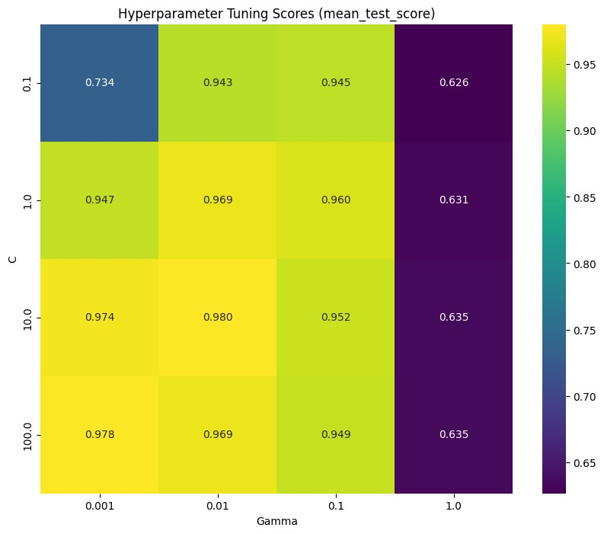

Final Conclusion
- SVM is effective for structured financial datasets.
- LinearSVC performs well on large datasets.
- Hyperparameter tuning significantly improves generalization.
- Feature scaling and class balancing are essential for optimal performance.
- The model successfully predicts credit default with strong classification performance.

